Previous Winners of the Eureka Democracy Award
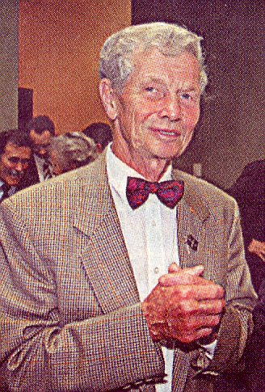
2008 - Weston Bate - Academic and historian
1953-1976 – Lecturer in history – University of Melbourne
1978-1989 – Foundation Professor of Australian Studies/Deakin University
Was: President - Royal Historical Society of Victoria and
Chair- Museum Advisory Board of Victoria of Ballarat
Historical consultant to Ballarat’s Gold Museum and Sovereign Hill Museum
An active, generous and passionate speaker about Eureka, his publications
Lucky City and Life After Gold present wonderful insights into the story of Eureka.

2009 - John Molony – Distinguished career as an academic and historian
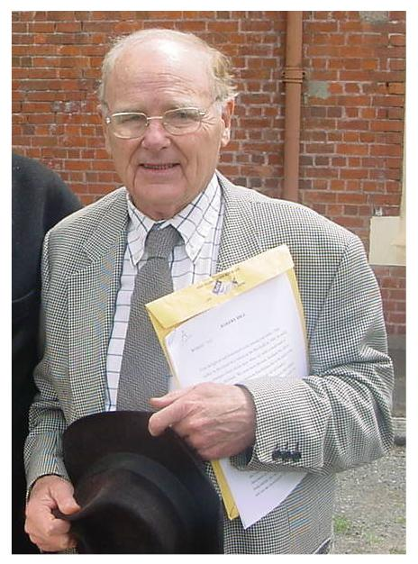
1964-1990 - Became Head of the Department of History and Manning Clark
Chair of Australian History at ANU
1990-1993 – Keith Cameron Professorship of Australian History at University
College Dublin
1993-1996 - Australian Catholic University - Foundation Research Professorship
in History
An active participant in various movements and causes.
A founding member of Eureka’s Children and now chairman of its Canberra Chapter
Among his many books is his highly acclaimed Eureka (3 editions)
Published and presented numerous reviews and articles on Eureka in academic journals and
major metropolitan newspapers as well as at seminars.

2010 - Margaret Rich, Director Ballarat Fine Art Gallery, 1980-2003.
For her contribution of conserving the Eureka Flag, developing a
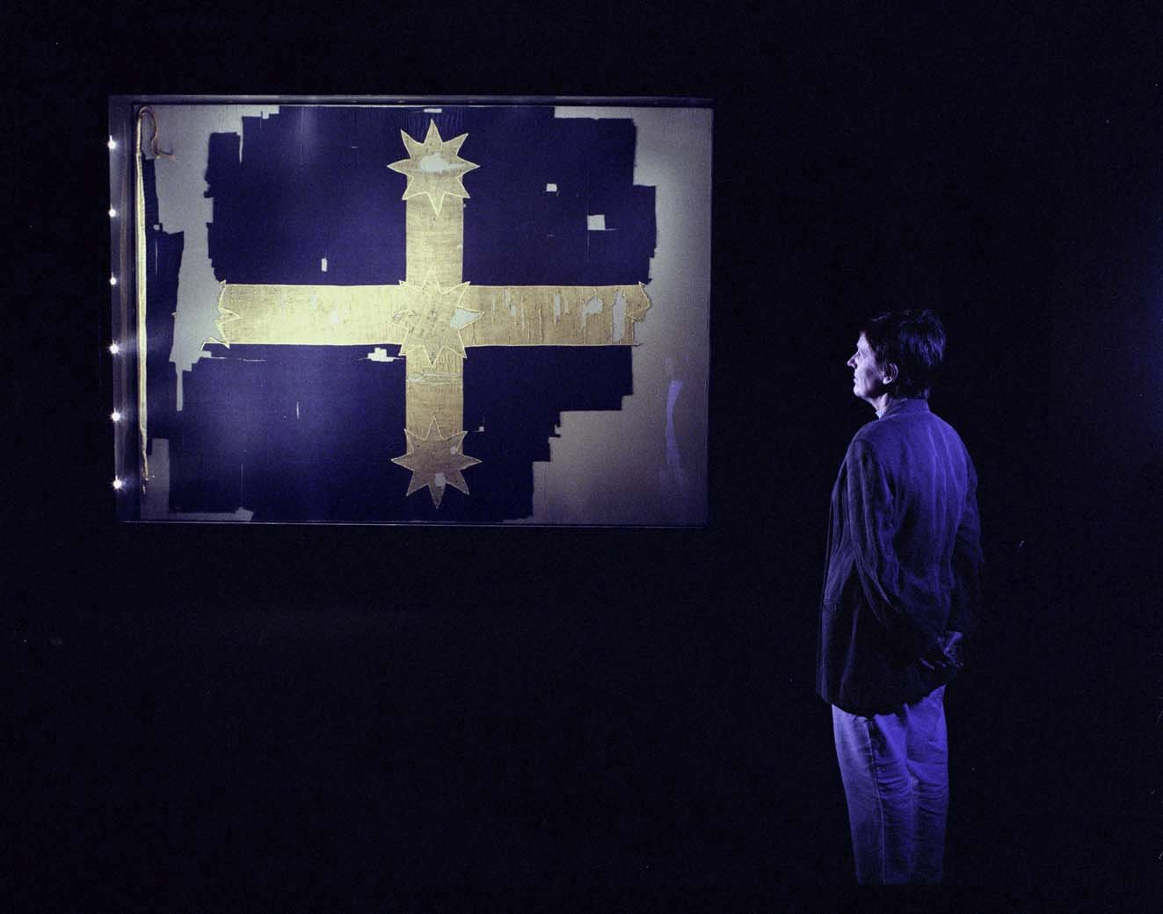
Eureka collection and presenting and exhibiting the story of Eureka
1994 – Presented with the Public Records Office of Victoria (PROV
Eureka 140 Exhibition – opened by Gough Whitlam
1996 – Involved in the video production: Flying the Flag
1996 – Acquired the Doudiet Eureka Sketchbook – Raising $245,000
1997 – Presented with PROV travelling exhibition
Eureka: The First Republic
2001 – Acquired State Government funding to give the Eureka Flag its
own special room and shrine in the gallery
2003 – Acquired Sydney Nolan’s Eureka inspired drawings
1998-2002 - Initiated and organized the Eureka Commemoration Dawn Lantern Walks
1999 - Founding member of the Ballarat Reform League Inc. dedicated to marking,
with memorials, key sites of democratic activism across Victoria’s goldfields

2011 – Dr. Anne Beggs Sunter - Author, Activist and Historian
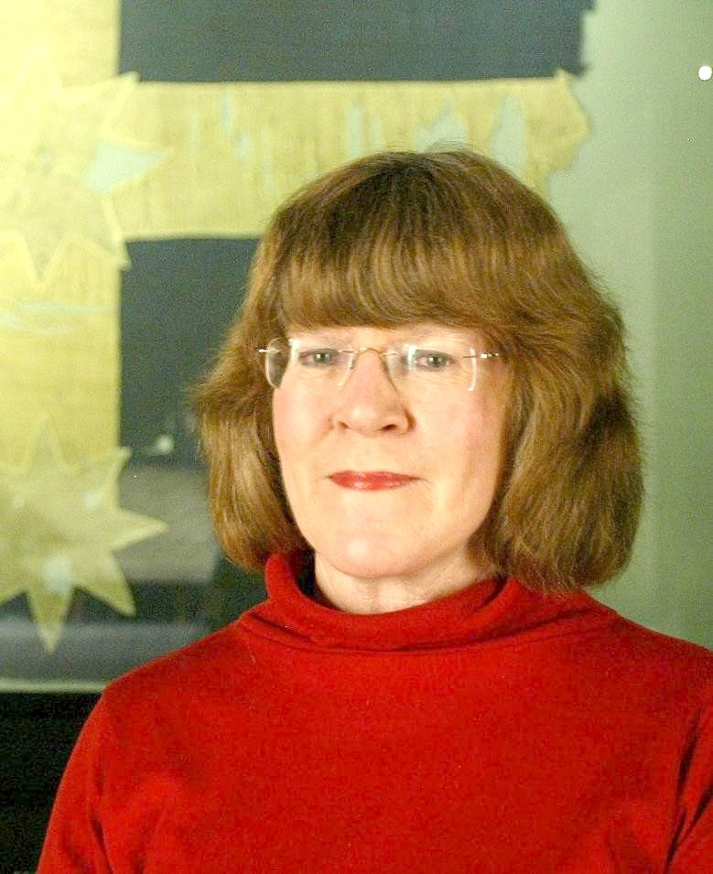
Made significant contributions over the past 35 years to preserving and
furthering the story of Eureka in her writings, educational programs
and campaigns
- Lecturer in history at University of Ballarat since 1974
- Anne’s doctoral thesis: “Birth of a Nation: Constructing and
De-constructing the Eureka Legend
- Published and presented numerous reviews and articles about Eureka
in academic journals and major newspapers as well as at seminars
- Involved in the preservation and restoration of the Eureka Flag as a
Committee member of the Ballarat Fine Art Gallery
- Wrote “Eureka Revisited: the Contest of Memories” and curated its complementary Exhibition which was presented at Old Parliament House in Canberra and the State Library in Victoria
- Member of the Save Bakery Hill Action Group that successfully saved this historical Eureka site from a “McDonalds” development project

2013 – Museum of Australian Democracy at Eureka (M.A.D.E.)
Eureka’s Children believe that the following four major elements are the reason for presenting the Eureka Democracy Award to MADE.

- It is a living Museum with activity and life - not just a Centre

- MADE links the Eureka Stockade story to the broader story of democracy and change.

- The Flag is now back at Eureka - for the first time since those who fought under it and fell, over 159 years ago. (Eureka’s Children respects and acknowledges the care and custodianship exercised by the Ballarat Fine Art Gallery over many years in the preservation and protection of the Flag. Their professional attention has preserved and promoted this Australian iconic symbol for the benefit of recent and future generations. We are all indebted to the Gallery Board, management and staff.)

- The Fallen at the Stockade are commemorated with a memorial and an avenue of honour in the grounds of MADE.
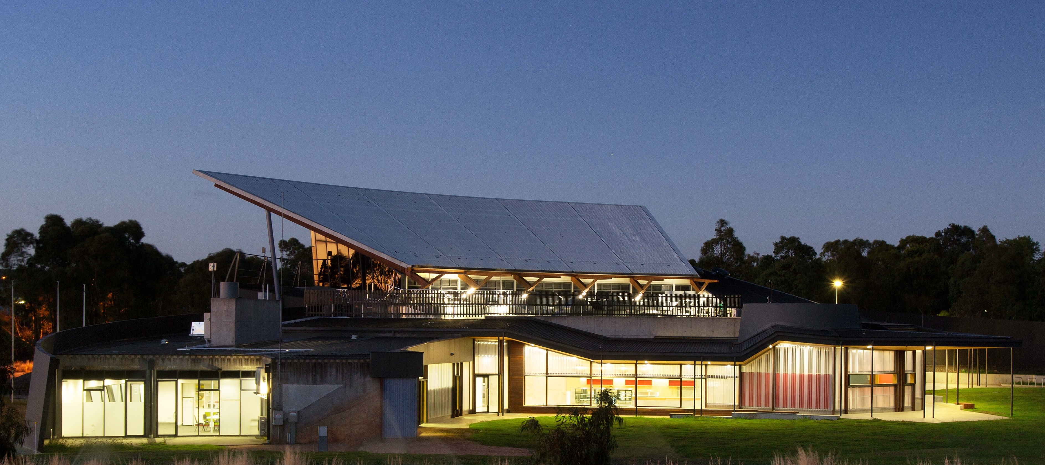

2015 – Father Frank Brennen
Father Frank Brennan SJ AO is a Jesuit priest, who has a longstanding reputation of advocacy in the areas of law, social justice, refugee protection and Aboriginal reconciliation. He is adjunct fellow in the Research School of Pacific and Asian Studies at the ANU, professor of law in the Institute of Legal Studies at the Australian Catholic University, and professor of human rights and social justice at the University of Notre Dame Australia. He was the founding director of Uniya, the Australian Jesuit Social Justice Centre.
Fr. Frank is one of Australia's leading advocates for justice and equity. His record on speaking out on behalf of people who have been ignored and disregarded in our community is unparalleled. He is known for his 1998 involvement in the Wik debate when Paul Keating called him "the meddling priest" and the National Trust classified him as a Living National Treasure.
Brennan is the first born son of Sir Gerard Brennan, a former Chief Justice of the High Court of Australia and Patricia O'Hara, an anaesthestist.
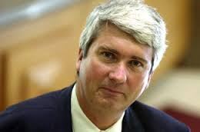

2016 – Phil Glendenning AM

Phil Glendenning is Director of the Edmund Rice Centre (ERC) and President of the Refugee Council of Australia. He was one of the co-founders of Australians for Native Title and Reconciliation (ANTaR) and for ten years was National President... He has served on the Boards of the Australian Council for Social Service (ACOSS), various committees of the Australian Council for Overseas Aid, and the Centre for an Ethical Society.
In recent years Phil led the Edmund Rice Centre's research team for the Deported To Danger series which monitored the safety of rejected asylum seekers in 22 countries, and resulted in an internationally screened documentary, “A Well Founded Fear”. With a background in education and political science, today he is primarily involved in human rights education, peace and reconciliation work and advocacy on climate change in Australia and internationally.

